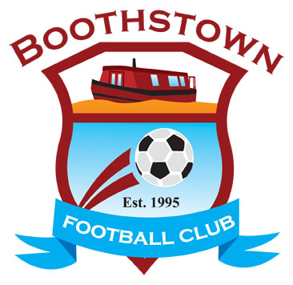
BOOTHSTOWN FOOTBALL CLUB

Club Secretary: Deborah Tinsley, 9 Queen Anne Drive, Ellenbrook, Manchester M28 1ZF

Hon. Presidents and Club Founders: David Lord and Paul Mallon (late)

02

20th August, 2019

Dear Parents/Carers,

Boothstown Football Club enables the young people to take part in a range of activities and events. During these photos and videos may be taken.

Child’s Name ________________________________ Team ____________________________

I am happy for photos/videos to be taken of my child and name, during club activities and events. I am happy for these to be used in Club publications and presentations and on digital channels (eg club website and social media).

I am happy for photos/videos to be taken of my child and name during club activities and events. I am happy for these to be used in Club only publications (eg Presentation Day).

I do not wish for any photograph/video to be taken of my child or named during Club activities and events.

Signature of Parent/Carer________________________________ Date __________________________

